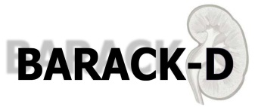

**BARACK D Trial:**

**A potential new treatment for kidney disease**

Pictureox blue 2 uni font**Participant Information Leaflet**

**Patient Information Booklet**

We would like to invite you to take part in our research trial. The trial is looking at a better treatment for preventing heart disease and kidney damage in people with chronic kidney disease, a term commonly used by doctors to describe a long-term impairment in kidney function, frequently accounted for by the natural ageing process, giving no sudden cause for concern.

Before you decide we would like you to understand why the research is being done and what it would involve for you. One of our team will go through the information sheet with you and answer any questions you have. We suggest you take time to read the information carefully and talk to others if you wish.

Thank you for taking the time to consider being part of this trial.

**Contact Details**

BARACK D Trial Team

Primary Medical Care

University of Southampton

Aldermoor Close

Southampton, SO16 5ST

Tel: 02380 241049

E-mail: barackd@soton.ac.uk

**PART 1**

**What is the Purpose of the Trial?**

Chronic kidney disease, a term commonly used by doctors to describe a long-term impairment in kidney function, frequently accounted for by the natural ageing process, is becoming increasingly common within the UK. It affects about 10% of the population. This is partly due to the fact that as a population we are living longer. However it is also because there are increases in other associated health problems including diabetes, obesity and high blood pressure. For these reasons, unlike many research studies, we are particularly interested in recruiting from the older age-group.

One of the concerns with chronic kidney disease is that it is linked to an increased chance of developing heart disease. This is because the kidneys are less effective at getting rid of waste products and excess fluid from the body. This in turn causes the heart to function less effectively. At the moment there are very few treatments available which reduce the amount of kidney damage and heart disease in people with chronic kidney disease.

In this trial we are looking at a drug called spironolactone to see whether it helps reduce heart disease and kidney damage in people with chronic kidney disease. Other studies have suggested that similar drugs may have this effect.

**Why have I been invited to take part?**

You have been invited to take part because your previous blood tests have shown that you have reduced kidney function or kidney disease. We are hoping to recruit a total of 2616 participants with this condition.

**Do I have to take part?**

No. It is up to you to decide to join the trial and if you do, you are free to withdraw at any time, without giving a reason. This would not affect the standard of care you receive.

**What will happen to me if I take part?**

If you decide you would like to take part you will be invited to attend a consultation at your own GP surgery. In this consultation, a suitably trained health professional will explain what you would have to do, give you some more information, and answer any questions you might have. If you would still like to participate you will be asked to sign a consent form. If you feel unsure you can ask to have another consultation and longer to think about it before starting the trial.

If you decide you do not wish to take part in the trial, you will be asked if we can use your medical records to provide data to compare with the results of the trial. You are free to decline this if you do not wish your records to be used. If you are happy for this to happen then you will be asked to sign a separate, shorter consent form.

Once you have signed the consent form, you will be asked some basic questions about yourself e.g. age. Depending on the results of your previous blood tests, you will fall into one of two cateogories:

1. You will have a quick blood test to check whether your results fall into the correct range for you to continue with the trial. If not, you will be invited back every three months until the end of the recruitment period to be re-checked. Once confirmation that your results are within range is received, you will be asked if you would like to continue with the remainder of the trial appointments (as described in 2, below).
2. You will be asked about your medical history and have your height, weight, waist circumference and blood pressure measured. You will have some blood tests taken and will have an ECG (painless heart tracing) carried out. You will also be asked to provide a urine sample.

A small number of participants will be chosen to have some extra tests. These will include having arterial ‘stiffness’ measured with a painless device which works like a very small ultrasound. This group will also need to wear a device which records your blood pressure over a 24 hour period. This will be required 5 times over the duration of the trial period.

Following this consultation you will be put randomly into one of two groups. Neither you, your GP nor any of the research team can choose which group you will be in. This is to make sure both groups are the same to start with, so that we can accurately compare which treatment is better.

One group will receive the standard treatment which people with chronic kidney disease are currently given. This may mean continuing with your current medication if you are already on treatment. The other group will receive this standard treatment but in addition will be given a tablet of spironolactone to take once a day. There is a 50% chance you will be in the group receiving the spironolactone.

**What is spironolactone?**

Spironolactone is a type of drug called an aldosterone receptor blocker. You may also hear it called an aldosterone antagonist diuretic. It helps remove extra water from the body so is often referred to as a ‘water tablet’. A particular characteristic of this water tablet is that it prevents excess potassium being flushed from the body in urine. You will have your potassium level monitored throughout the trial by a simple blood test. Spironolactone has been used for many years for treating various conditions including those which result in excess fluid in the body. Taking it will make you need to pass urine more frequently. It is therefore recommended you take it in the morning.

**Expenses and Payment**

You will not be paid for taking part in this trial however receipted and reasonable travel expenses for visits additional to standard care can be reimbursed as your involvement in the trial may result in you being asked to attend more clinics at your GP surgery than you may otherwise be required to attend.

**What will I have to do?**

If you decide you would like to take part, you will attend your first consultation at your GP surgery. This is described in the section ‘What will happen to me if I take part?’ The trial will be conducted over 156 weeks (36 months) and you will need to attend your GP surgery for follow up appointments at weeks 1,2,4,12,26, and then approximately every 13 weeks up until 156 weeks.

Depending on which visit you are attending, you may also have blood tests, have your blood pressure measured, be asked to provide a urine sample and be given a questionnaire to fill out. On some weeks we will also ask you to check your own blood pressure at home. You will be shown how to do this and provided with the equipment needed.

The blood tests that will be performed will look at overall blood composition (full blood count), kidney health (renal and bone profile), long and short-term blood sugar levels (HbA1C and fasting blood) and heart health (lipids and BNP).

Throughout this time period you will remain in the same group you are assigned to at the beginning. You will need to continue taking the treatment as indicated unless specifically advised to stop by your GP. You can continue any other medication you normally take. However, if this medication changes at any point during the trial period you should inform your GP if he/she was not involved in the decision to change it. You will be given a diary to fill in at home to record any medications you are taking whilst on the trial.

**What are the risks in taking part in this trial?**

All participants in this trial will be receiving the normal routine care for chronic kidney disease from their GP. Therefore, participants who are in the group not given spironolactone will be at no further risk by taking part.

As with all medications, there are side effects (adverse events) you may experience when taking spironolactone. In a large research trial of patients taking spironolactone compared with an inactive (placebo) tablet, 1 in 10 men experienced breast discomfort or swelling, compared with 1 in 100 men taking the inactive (placebo) tablet over a two year period. However, the main safety concern for spironolactone is that it can increase the level of potassium in the blood and this is why we will take frequent blood samples in the early part of the trial. Previous research studies have shown that 2 in 100 people taking spironolactone develop a high potassium which is detected by the frequent blood tests and treated by reducing the dose of spironolactone. Very rarely, spironolactone needs to be stopped completely, but this only occurs for 1 in 200 patients given spironolactone.

Having said this, spironolactone is a medication that has been used for various conditions for many years and is considered safe to take for people with no sensitivity to it. You will be closely monitored whilst in the trial.

W**hat are the benefits of taking part?**

If you are in the group that does not receive the spironolactone, there will be no clear additional benefits for you in taking part in the trial. However you will have the knowledge that you have contributed to research which helps develop better treatments for people suffering from chronic kidney disease.

If you are in the group which does receive spironolactone there is the possibility that this may give you protection against further kidney damage and heart disease. However we will not know if this is the case until after the trial is finished.

**What if I become unwell during the trial?**

If you become unwell, need to attend hospital for any reason or change your normal medication whilst you are in the trial you should inform your GP. We will need to record this in our trial documents.

If you are in the group taking spironolactone and become unwell, your GP may ask you to reduce your dose or stop taking it either for a short period of time or permanently. If the reason you are unwell is because you are experiencing a side effect associated with spironolactone your GP will stop you taking it. You can also request to stop taking it at any time.

**What are the alternative treatments?**

Both groups in this trial will be receiving the standard treatment and care recommended for people with chronic kidney disease. If you are in the group receiving the additional spironolactone and become unwell as a result, you will be taken off this and will revert to standard care.

**What happens to me when the research trial is finished?**

Your active participation in the trial will continue for 156 weeks. After this you may be followed up by your GP and the research team at 5 years.

**What if there are any problems?**

Any complaint about the way you have been dealt with during the trial or any possible harm you might suffer will be addressed. The detailed information on this is given in Part 2.

**Will my participation and personal records be kept confidential?**

Yes. All data will be kept securely according to the Data Protection Act 1998 and the research team have a duty of confidentiality to you as a research participant. The contact details that you provide will be kept securely in a restricted access location within Primary Medical Care, Aldermoor Close, Southampton. Access will be granted only to appropriate members of the trial research team.

All trial information collected will be made anonymous at the earliest practical opportunity. The information you provide at the first consultation and subsequent appointments, will be coded with a trial identification number so you cannot be identified from it by anyone other than the research team. Responsible members of the University of Oxford, the NHS Trust or the Medicines and Healthcare products Regulatory Agency (MHRA) may be given access to anonymous data for monitoring and/or audit of the trial to ensure we are complying with regulations.

**PART 2**

**What if relevant new information becomes available during the trial?**

Sometimes we get new information about the treatment being studied. If this happens, your GP will tell you and discuss whether you should continue in the trial. If you decide not to carry on, your GP will make arrangements for your care to continue. If you decide to continue in the trial he/she may ask you to sign an agreement outlining the discussion.

**What will happen if I want to stop taking part in the trial?**

You are free to leave the trial at any point. It would be useful for us to use any information or samples you have already provided. However, if you would like these samples/information to be withdrawn then you can request this. Leaving the trial will not affect the treatment you receive from your GP. If you have any concerns once you have left the trial you will still be able to contact the research team for help and advice.

**What if there are any problems?**

If you have any queries about this trial then please contact the trial co-ordinator. The University of Oxford, as the Research Sponsor of this trial, holds appropriate insurance cover in respect of any acts or omissions for which the University is legally liable.

If you wish to complain about any aspect of the way in which you have been approached or treated during the course of this trial, you should contact the trial co-ordinator, in the first instance, or you may contact the University of Oxford Clinical Trials and Research Governance (CTRG) office on 01865 572224 or the head of CTRG (email: [ctrg@admin.ox.ac.uk](mailto:ctrg@admin.ox.ac.uk)). The NHS Patient Advice and Liaison Service (PALS) is also available at <http://www.pals.nhs.uk/>.

The University has arrangements in place to provide for harm arising from participation in any trial for which the University is the Research Sponsor. NHS indemnity operates in respect of the clinical treatment with which you are provided.

**What will happen to any samples I give?**

During the trial we will ask you for blood and urine samples. Your GP will use the results from these samples to monitor your condition. Your GP will therefore have access to any unexpected results that are discovered during the trial and will be able to act on them appropriately. Information from these samples will be made anonymous as soon as practically possible for use by the research team.

**What will happen to the results of the research trial?**

The results of this research trial will be published in a scientific medical journal, most probably sometime after the trial has finished. Your individual results would not be identifiable nor would you be identified in any report or publication. Your GP will have access to your personal results, which will be stored in your medical notes, and will address any that are unusual.

**Who is organising and funding the research?**

This trial is being funded by the National Institute for Health Research, Health Technology Assessment Programme.

**Who has reviewed the trial?**

All research in the NHS is looked at by an independent group of people, called a Research Ethics Committee, to protect your interests. This trial has been reviewed and given favourable opinion by South Central Oxford B Research Ethics Committee.

**Further information and contact details**

If you would like any further information about this trial you can contact the research team by telephone on 02380 241049 or e-mail at jab6@soton.ac.uk. For further independent advice you can contact INVOLVE ([www.invo.org.uk](http://www.invo.org.uk)) which is a government funded national advisory group to support people taking part in NHS, public health or social care research.

Yours sincerely,

Prof Richard Hobbs Professor Paul Little Jane Barnett

Chief Investigator Principal Investigator Trial Manager

**Flowchart for Trial Visits**

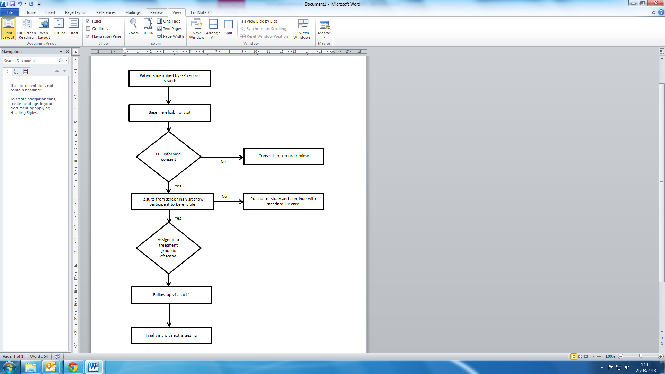

**Timetable for Trial Visits**

|  |  |  |  |  |  |  |  |  |  |  |  |  |  |  |  |  |  |
| --- | --- | --- | --- | --- | --- | --- | --- | --- | --- | --- | --- | --- | --- | --- | --- | --- | --- |
| **Week number** | **S** | **0** | **1** | **2** | **4** | **12** | **26** | **39** | **52** | **65** | **78** | **91** | **104** | **117** | **130** | **143** | **156** |
| **Visit Number** | **0** | **1** | **2** | **3** | **4** | **5** | **6** | **7** | **8** | **9** | **10** | **11** | **12** | **13** | **14** | **15** |
| Consent to take part in trial | Blood result confirmation visit (where applicable) – repeated every 3 months for duration of recruitment period (including blood test and informed consent). | X |  |  |  |  |  |  |  |  |  |  |  |  |  |  |  |
| Details about yourself eg name, age etc | X |  |  |  |  |  |  |  |  |  |  |  |  |  |  |  |
| Confirm medical history and any medications you are on | X |  |  |  | X | X |  | X |  | X |  | X |  | X |  | X |
| Measure height, weight and waist circumference | X |  |  |  |  |  |  |  |  |  |  |  |  |  |  | X |
| Physical examination by doctor | X |  |  |  |  |  |  |  |  |  |  |  |  |  |  |  |
| Allocation to one of two groups | X |  |  |  |  |  |  |  |  |  |  |  |  |  |  |  |
| Measure blood pressure in surgery | X | X | X | X | X | X | X | X | X | X | X | X | X | X | X | X |
| Blood pressure readings from home |  |  |  |  | X |  |  | X |  | X |  | X |  | X |  | X |
| Questionnaire on your daily life | X |  |  |  |  | X |  | X |  |  |  | X |  |  |  | X |
| Look at diary card for medication | X |  |  |  | X | X |  | X |  | X |  | X |  | X |  | X |
| Adverse event/ill effect monitoring | X | X | X | X | X | X | X | X | X | X | X | X | X | X | X | X |
| Urine sample | X |  |  |  |  |  |  |  |  |  |  |  |  |  |  | X |
| Heart tracing (ECG) | X |  |  |  |  |  |  |  |  |  |  |  |  |  |  | X |
| Blood tests | X | X | X | X | X | X | X | X | X | X | X | X | X | X | X | X |
| **A small number of participants will also have the following** | | | | | | | | | | | | | | | | | |
| Measurement of Arterial Stiffness |  | X |  |  |  |  | X |  | X |  |  |  | X |  |  |  | X |
| 24 hour blood pressure monitoring | X |  |  |  |  | X |  | X |  |  |  | X |  |  |  | X |



**Benefits of Aldosterone Receptor Antagonism in Chronic Kidney Disease**

Pictureox blue 2 uni font**Reply Slip**

***You can either E-mail us at: Barackd@soton.ac.uk***

***OR***

***Telephone us on: 02380 241049/241076***

***OR***

***Complete this reply slip and return in the enclosed pre-paid envelope***

☐ **I would like to take part in this study.** Please contact me.

I realise that this is not a commitment to taking part in the study.

☐ **I would like to know more about the study.** Please contact me.

I realise that this is not a commitment to taking part in the study.

|  |  |
| --- | --- |
| **Name** |  |
| **Date of birth** |  |
| **Your address** |  |
| **Phone number**  (and best time to call) |  |
| **Email address** |  |
| **Surgery name** |  |

☐ **I do not wish to be included in this study**.

We will assume that you do not want to take part in the study if we do not hear

from you. However, you are still welcome to tick the ’No’ box above and provide

feedback if you wish.

